Quiz 2
MATH 131
Summer 2017
Sections 3.1-3.3
Show all work for full credit. Good luck!
1. Find the equation of the tangent line to the given curve at the specified point.
$$y=2xe^{x}+311 , (0,311)$$

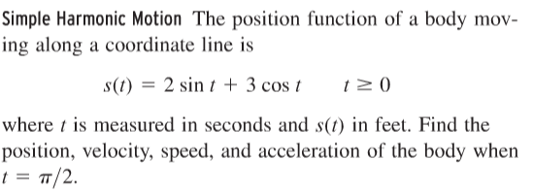
2.

3. Differentiate (but do not simplify).

$$y=\frac{te^{t}}{4+t}$$

